Product Note on
Chella Chat
A chatbot, mobile app for financial services

Table of Contents
1 Statement of Confidentiality 3
2 Overview 4
3 How investors can use Chella chat 4
3.1 Request to open new trading account with preferred brokers. 4
3.2 Trading 4
3.3 Statements and reports 4
3.4 Straight through processing of orders 5
3.5 Pilot phase will be on Android 5
3.6 No additional hardware resources required 5
4 Images of Chella chat 6

Statement of Confidentiality
This document contains proprietary and confidential information about Chella Software Private Limited (Chella Software). This information is provided for the sole purpose of permitting the recipient to evaluate the information contained herein. In consideration of receipt of this document, the recipient agrees to maintain such information in confidence and is not to reproduce or otherwise disclose or distribute this information to any person outside of the group directly responsible for evaluation of its contents, without the express written permission of Chella Software. Use or disclosure of this document in whole or in part for purposes other than the pursuit of a business relationship with Chella Software is expressly forbidden.

Overview
Chella Chat is a chatbot based mobile app for financial services, developed by Chella Software private limited. This app allows investors transact/trade with their broker through chat based interactions/conversations. The app facilitates the investors with the below functions
- Buy and sell shares on NSE
- Manage their trading activities
- View their portfolio and various account details
- New customers can send a request to the broker to open a trading account

How investors can use Chella chat
Chella chat allows investors to buy and sell shares through a chat based interface. The chatbot engine of Chella chat automates the process and interacts with the user using regular chat messages. In addition to trading, an investor can view holdings, check their order status, modify / cancel orders and carry out many account related functions. The activities that can be done through Chella chat are

Request to open new trading account with preferred brokers.
Investors who do not have a trading account, can send a request to their chosen broker to open an account. The broker will get in touch with the client to complete the account opening processes.

Trading
Chella chat allows investors to trade in real-time. Investors will be able to see the closing price of the security and place an order on the exchange. Chella chat connects with the broker back office and hence orders placed are routed to the exchange through the brokers BBO infrastructure. Investors can carry out the following
- Place a buy or a sell order for the selected stock
- Modify an existing order
- Cancel an existing order

Statements and reports
Investors can view and self-manage their accounts through Chella chat. The following information can be viewed by the investors.
- Status of the orders placed.
- Portfolio valuation of the stocks held
- Mini Statement which displays the last five transactions done by the investor.
- View ledger balance and the available funds.
- Closing price of selected stocks
- Market status.

Straight through processing of orders
- Chella chat integrates with BBO through APIs. Any transaction done in Chella chat is reflected in ClearVision in real time and vice versa.
- All orders placed through Chella chat are risk checked in ClearVision, in real time, for necessary funds /stocks before being accepted. If the investor does not have adequate buying power or shares in the account, the order is rejected.

Pilot phase will be on Android
- In the pilot phase, Chella chat will be available on Android
- The iOS version will be launched in a few weeks from now based on the traction that is seen with the Android app

Images of Chella chat
Login screens
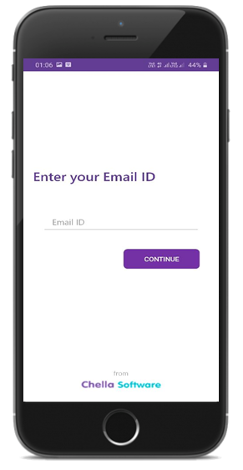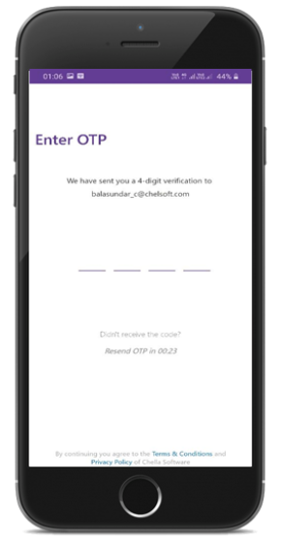
Home Screen
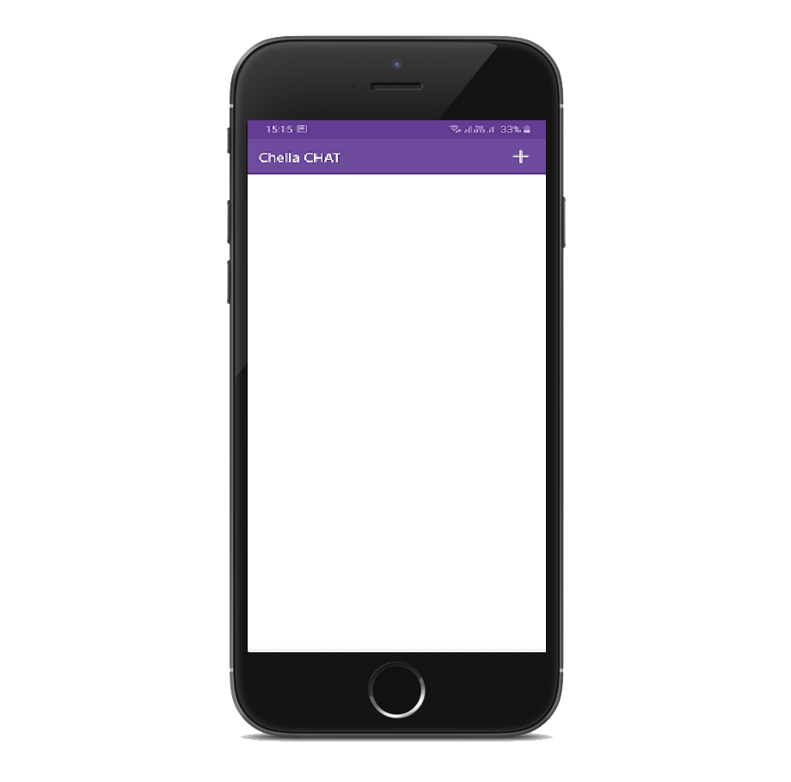
Broker Selection
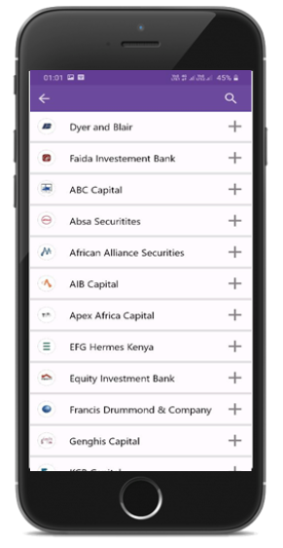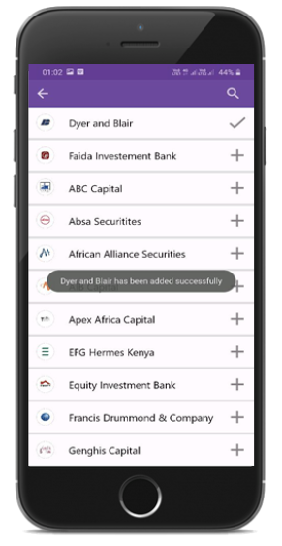
Brokers welcome screen
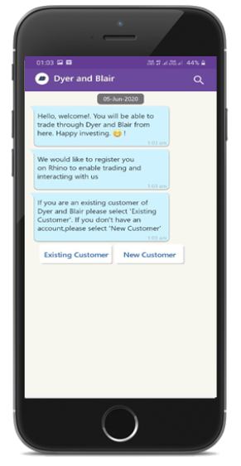
New acount opening request
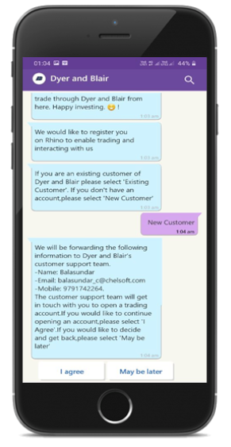
Options for existing customers
